**CST-256 Design Report**

| **Topic:** | *Milestone Project* | |
| --- | --- | --- |
| **Date:** | *6/26/2022* | |
| **Revision:** | *1.0* | |
| **Team:** | 1. Tanner Ray | |
| 1. Hiram Viezca | |
| 1. Zachary Swogger | |
| 1. Kurt Newcomb | |
| **Weekly Team Status Summary:** | | **User Story** | **Team**  **Member** | **Hours**  **Worked** | **Hours Remaining** | | --- | --- | --- | --- | | *login view and back end* | *Tanner* | *3* | *0* | | *registration view and back end* | *Hiram* | *2* | *0* | | *home page and navigation* | *Tanner* | *3* | *0* | | *diagrams* | *Zachary* | *1* | *0* | | *project report compilation* | *Kurt* | *1* | *0* | | *flowchart* | *Kurt* | *1* | *0* | |  |  |  |  | |  |  |  |  | |  |  |  |  | |  |  |  |  | |  |  |  |  | |  |  |  |  | |  |  |  |  | | |
| **GIT URL:** | *https://github.com/tray15/CST256* | |
| **Hosting URL:** | *N/A* | |
| **Peer Review:** | *Y* | We acknowledge that our team has reviewed this report and we agree to the approach we are all taking. |

**Design Documentation**

**Install Instructions:**

MAMP - Install a version of MAMP that supports php 7.4.16, installing any of the extras like MAMP PRO is unnecessary. The current version of MAMP should do just fine.

PHP Version: 7.4.16 - Should come with MAMP  
Composer - Go to the website and download the latest version. ([Composer (getcomposer.org)](https://getcomposer.org/download/))

IDE: Eclipse for PHP Developers - Download the Eclipse installer and make sure you select the Eclipse for PHP Developers option.

Laravel Version: 5.5.28 - During project creation in eclipse you enter laravel/laravel and select version 5.5.28  
  
  
Important Note: Make sure all applications are set to the same version of PHP. To help facilitate this, I recommend installing the applications in the listed order.

**General Technical Approach:**

The general technical approach we are taking with this project is a ground up approach. None of us have previous experience with the Laravel framework, so we are keeping things simple to allow all project team members to understand all aspects of the project.

**Key Technical Design Decisions:**

Our choice of framework was essentially chosen for us by the class, as well as technical issues for most team members during setup. The class dictated the use of Eclipse as the IDE, but during setup several team members had issues with an openssl extension during project setup with the laravel 5.5.28 framework. The issues persisted for those group members for a substantial period of weeks 1 and 2 but have seemingly been solved. In the process of solving the errors for the team, we all seemed to settle on PHP 7.4.16.

**ER Diagram:**

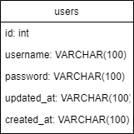

**DDL Scripts:**

[*CST256/cst256milestone.sql at main · tray15/CST256 (github.com)*](https://github.com/tray15/CST256/blob/main/cst256milestone.sql)

**Sitemap Diagram:**

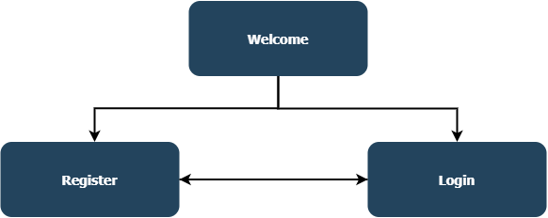

**Security Design:**

Currently, our security designs are limited to login and registration pages.

**Third Party Interface Design:**

N/A, as we are not currently utilizing any third party interfaces.

**Flowcharts:**

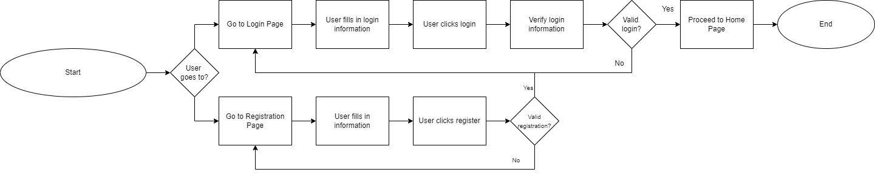

**User Interface Diagrams:**

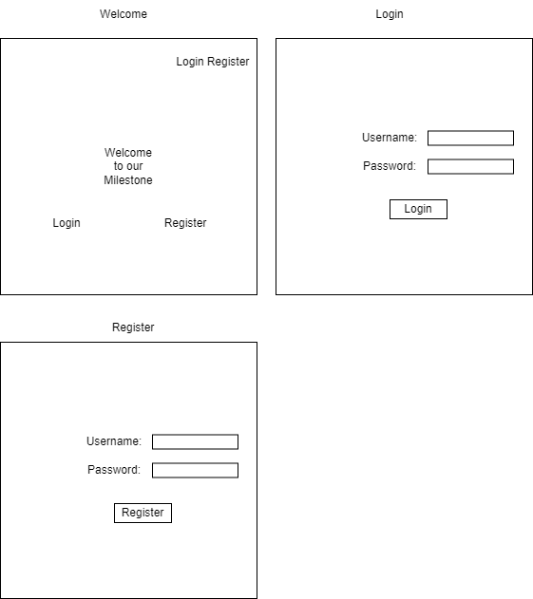

**Class Diagrams:**

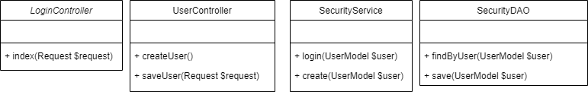

**Pseudo Code:**

N/A, we currently don’t have any pseudo-code written up.

**Other Documentation:**

N/A, no other random documents needed at this time.